26.57:
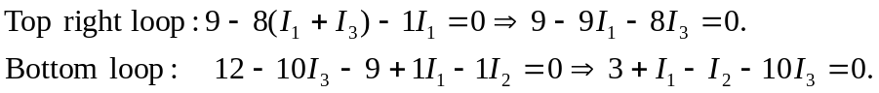
Solving these three equations for the currents yields:

